Harmonics Measurement

Abstract
This document presents the results of harmonic measurement, which starts with an introduction of the measurement methods and devices. It incorporates the followings:
- Measurement Methods and Devices
- Requirements
- Available Devices

1. Measurement Devices

1.1 Requirements
Oscilloscopes alone cannot accurate quantify certain harmonics. However, most oscilloscopes in the market have integrated digital analysers and are able to perform Fast Fourier Transform. The trade-off of the comprehensive functions of oscilloscopes is their constraint mobility.
Another option is hand-held clamping devices which can measure harmonics without connecting them directly to the wire. In this way, fewer connection are needed which simplified the circuitry systems. Additionally, harmonics of any specific wire can be measured.
The parameters are specified as shown
Maximum Input Voltage (V) | >220
Bandwidth (Hz) | 20k-30k
FFT Functions | Yes
THD Analysis | Yes

1.2 Available Devices

1.2.1 Oscilloscopes/Non-Clamped Devices
1) BK Precision 2530B and 2532B Digital Storage Oscilloscope
Maximum Input Voltage | 400 V
Rise time (ns) | <8.8
Bandwidth (Hz) | 25 MHz
FFT Functions | Yes
THD Analysis | No
Channels | 2
Price (USD) | 449.00
It includes PC software that can be used to control the instrument remotely and do the THD analysis on the data retrieved from the oscilloscope.

2) Fluke 43B Power Quality Analyzer
Maximum Input Voltage | 600 V
Bandwidth (Hz) | 10 – 15 MHz
FFT Functions | Yes
THD Analysis | Yes
Price (USD) | 3,299.95
The Power Quality Analyzer is a comprehensive testing device which can performs the followings:
- Calculates 3-phase power on balanced loads, from a single-phase measurement
- Trends voltage, current, frequency, power harmonics and captures voltage sags, transients and inrush current
- Its FlukeView® Software can log harmonics and all other readings over time and provides a complete harmonics profile up to the 51st harmonic
- 20 measurement memories to save/recall screens and data with cursor readings
- Measures resistance, diode voltage drop, continuity, and capacitance
- Complete package with voltage probes and 400 A current clamp
However, its price is considerably large

3) DS1000E Series Digital Oscilloscope
Maximum Input Voltage | 300 V
Bandwidth (Hz) | 50 MHz
FFT Functions | Yes
THD Analysis | No
Price (USD) | 329
- Relatively cheap price
- Compact in size
- Software control package
- LabVIEW drivers available; Able to communicate with MATLAB ^{[1]}
- Collect data after each trigger event
- Can be used as automated data acquisition systems
- Capture rate 500M Sample/s to 1G Sample/s
Note: This oscilloscope is the one that EMHeater uses.

1.2.2 Hand Held/Clamped Devices
4) AMEC Instruments – 407 General Purpose Clamp-on Meters
Maximum Measured Voltage | 1400 Vp
Maximum Measured Current | 2000 A_{AC}
Bandwidth | 20kHz
Price (USD) | 450.00
- Measures harmonics up to 25th
_ Bluetooth communication
- Recording frequency 1Hz

5) JYE Tech DSO 094
Maximum Measured Voltage | 50 Vp (1x probe)  400 Vp (10x probe)
Bandwidth | 10MHz
Sampling rate | 50MSa/s
Max. Recorded Length | 8000 points
FFT Functions | Yes
THD Analysis | No
Price (USD) | 157.00
- Accompanied with software JYElab
- Need manual calibration for 10x probe
- Bugs in software JYElab

1.2.3 Comments on Available Devices
Personally, I prefer 3) and 4). Both devices are able to measure harmonics up to 25th and their prices are competitive. 3) is an oscilloscope which can display voltage and current waveforms, whilst 4) is easy to use because it features a clamp. 1) has similar functions with 2) but the price is higher. 5) is an innovative device that would be an optimal choice if they developed a better software with less bugs and an more accurate way for calibration.

2. Total Harmonics Distortion Calculations
The total harmonic distortion (THD) of a signal is a measurement of the harmonic distortion present. THD is defined as the ratio of the sum of the powers of all harmonic components to the power of the fundamental frequency. With such definition, THD can be calculated basing on voltages [2]
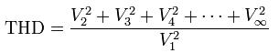

where V₁ is the voltage amplitude of the fundamental component while V_{k} (k=2, 3, …) is the voltage amplitude of the k^{th} harmonic component.

To calculate the THD for an unknown signal, we need to know the amplitude for each harmonic. The amplitudes are obtained by Fourier analysis. MATLAB adopts fast Fourier Transform (FFT) algorithm to compute discrete Fourier Transform.
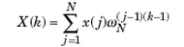

In three-phase power system, even harmonics generally do not exist. Also, the coefficients of higher harmonics are insignificant. Therefore, we use the coefficients of the 3rd, 5th, 7th and 9th harmonics to calculate THD
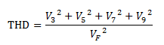

The code (See Appendix I) used to calculate THD has been tested with several signals. The example below demonstrates the validity of the code:
The original signal is

with a fundamental frequency of 50Hz.
The original signal is distorted by harmonics:
The THD calculated directly from this expression is 0.0064.

Now using FFT in MATLAB, the spectrum of the system is obtained as shown below
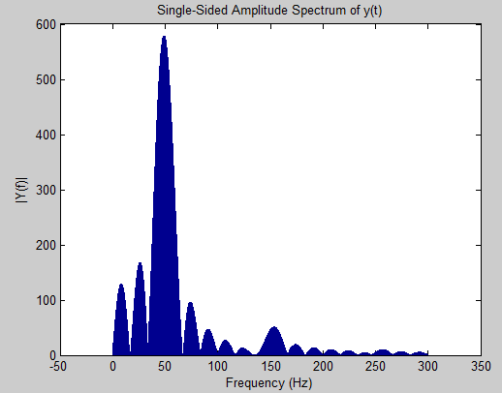

The coefficients of the 3rd, 5th, 7th and 9th components can be found to be 577.6998, 46.0800, 5.5852, 0.2078 and 3.5453e-14, respectively. The THD from Fourier analysis is evaluated to be 0.0065. Comparing to the THD calculated directly from the expression 0.064, we can conclude that the THD method is valid.
The error can be reduced by increasing the length of DFT (N value). The upper bond of N is limited by the memory of the computation device.
MATLAB 2012a does not offer a single function to calculate THD. However, it does FFT analysis and THD calculation in SIMULINK using a similar algorithm.

Reference
[1] J. Chonko, E-mail, Available e-mail: jason_chonko@rigol.com
[2] Slone, G. Randy, The audiophile's project sourcebook. McGraw-Hill/TAB Electronics, 2001

Appendix I

